**Title: FitMod - Your Healthcare Companion**

**Team Members**

PES2UG21CS263 - M.Nikita Mabel

PES2UG21CS271 - Malavika V

PES2UG20CS347 - Sree Hema Hasmita Kancharla

**Abstract**

With an increase in health issues over the recent years, the general population is much more informed about health risks and performs regular health checkups. However, a common problem that was noticed was how they did not have any provision to store all their test report data at a single location. Thus, a prototype GUI application, called FitMod, has been developed, so as to collect and generate instant health reports, analyse health parameters, consolidate all data entered and store it for future retrieval and also to assess a user’s health in the long run.

**Table of Contents**

| **Title** | **Page No.** |
| --- | --- |
| Introduction | 1 |
| Design/Implementation | 2 |
| Testing | 45 |
| Result and Analysis | 48 |
| Conclusions and Future Enhancements | 53 |
| References | 54 |

**Introduction**

Fitmod: Your Healthcare Companion, is an initiative made to assist users to monitor and track their health without any hassle. The aim of our computer project is to come up with a prototype platform which can be used by users to upload their health reports, get analysis based on data provided, track their health history over time and to avail healthcare specialists depending on need.

The key feature of our project is our integration of two different programming languages, Python and SQL. Using Python, we have created a user-friendly GUI interface, with which we ask the required information from the user.

To enhance the user’s participation and to make our project less readable and more visual, we have used data visualisation such as graphs through matplotlib pyplot module. We have also made use of the python GUI library, tkinter, which is used to bring in graphics into python, to make it look more attractive. Also, this program has 33 user-defined functions.

SQL is used to store the data of a user’s health so that they can access and update it whenever required. Every user has a separate table dedicated to maintaining their reports. If a new user enters his/her data, a corresponding table in their name will automatically be created to store the current and future data. This functionality is done by using the Python SQL connector.

**Design/Implementation**

**# importing modules**

import tkinter

from tkinter import *

import tkinter.font as f

import mysql.connector

from tkinter import messagebox

from tkinter import ttk

from datetime import *

**#Connecting to MySQL**

mydb = {'user': 'root', 'password': 'Sqlpy@Thon13', 'host': 'localhost',

'database': 'fitmod', 'port': 3306,'raise_on_warnings': True}

global mycon

mycon = mysql.connector.connect(**mydb)

global mycursor

mycursor = mycon.cursor()

def connectionMYSQL():

mydb = {'user': 'root', 'password': 'Sqlpy@Thon13', 'host': 'localhost', 'database': 'fitmod',

'port':3306, 'raise_on_warnings': True}

global mycon

mycon = mysql.connector.connect(**mydb)

global mycursor

mycursor = mycon.cursor()

**#Introduction Page**

def main(root=None):

if root != None:

root.destroy()

intro = Tk()

intro.title("FitMod")

intro.geometry("1920x1080")

bg =PhotoImage(file="C:/Users/micha/OneDrive/Desktop/nikipython/fitmod/Intro_FitMod.png")

label = Label(intro, image=bg)

label.place(x=0, y=0, relwidth=1, relheight=1)

login_b = Button(intro, text="LOGIN", background="#77CC97", command=lambda:

(loginwindow(intro)))

loginfont = f.Font(family="Oswald", size=20)

login_b['font'] = loginfont

login_b.place(x=710, y=396)

intro.mainloop()

**#Login Window**

def loginwindow(root):

root.destroy()

root = Tk()

root.title("FitMod-Login")

root.geometry("1920x1080")

bg = PhotoImage(file="C:/Users/micha/OneDrive/Desktop/nikipython/fitmod/Login_new.png")

label = Label(root, image=bg)

label.place(x=0, y=0, relwidth=1, relheight=1)

**# Password Check Function**

def CheckPswd():

uname = nameEntry.get()

pswd = passwordEntry.get()

if uname == "admin" and pswd == "admin@123":

dashboard(root)

else:

messagebox.showwarning("Warning", "Entered Username or Password is Incorrect")

nameEntry = Entry(root, font=('Poppins', 15))

nameEntry.place(x=780, y=375, width=150, height=35)

passwordEntry = Entry(root, font=('Poppins', 15))

passwordEntry.place(x=780, y=435, width=150, height=35)

cont = Button(root, height=1, width=10, text="CONTINUE", background="#f2c2a6",

foreground="#000000", command=CheckPswd)

contfont = f.Font(family="Poppins", size=19)

cont['font'] = contfont

cont.place(x=710, y=520)

home_b = Button(root, text="HOME", background="#d4e4ed", height=1, width=10,

foreground="#000000",command=lambda: main(root))

homefont = f.Font(family="Poppins", size=15)

home_b['font'] = homefont

home_b.place(x=1300, y=700)

root.mainloop()

**#Dashboard Page(after login)**

def dashboard(r):

r.destroy()

r = Tk()

r.title("FitMod-Home Page")

r.geometry("1920x1080")

home = PhotoImage(file="C:/Users/micha/OneDrive/Desktop/nikipython/fitmod/

DashboardTrial.png")

label = Label(r, image=home)

label.place(x=0, y=0, relwidth=1, relheight=1)

upload = Button(r, text="UPLOAD HEALTH REPORT",

background="#f3b4a3", command=lambda:(uploadhealth(r)))

uploadfont = f.Font(family="Poppins", size=13)

upload['font'] = uploadfont

upload.place(x=215, y=460)

view = Button(r, text="HEALTH HISTORY",

background="#f3b4a3",command=lambda:(HealthHistory(r)))

viewfont = f.Font(family="Poppins", size=13)

view['font'] = viewfont

view.place(x=700, y=460)

doc = Button(r, text="CONTACT DOCTORS", background="#f3b4a3", command=lambda:

(consult(r)))

docfont = f.Font(family="Poppins", size=13)

doc['font'] = docfont

doc.place(x=1130, y=460)

l = Button(r, text="LOG OUT", background="#b4e1c3", command=lambda: (loginwindow(r)))

lfont = f.Font(family="Poppins", size=13)

l['font'] = lfont

l.place(x=1330, y=730)

r.mainloop()

**#Doctor Categories Page**

def consult(d):

d.destroy()

d=Tk()

d.title("Contact Doctors")

d.geometry("1920x1080")

dpg=PhotoImage(file="C:/Users/micha/OneDrive/Desktop/nikipython/fitmod/contactdoc.png")

label=Label(d,image=dpg)

label.place(x=0,y=0,relwidth=1, relheight=1)

dp=PhotoImage(file="C:/Users/micha/OneDrive/Desktop/nikipython/fitmod/baby.png")

b1=Button(d,image=dp,command=lambda:(ped(d)))

b1font=f.Font(family="Oswald")

b1['font']=b1font

b1.place(x=180,y=200)

dp1=PhotoImage(file="C:/Users/micha/OneDrive/Desktop/nikipython/fitmod/heart.png")

b2=Button(d,image=dp1,command=lambda:(card(d)))

b2font=f.Font(family="Oswald")

b2['font']=b2font

b2.place(x=500,y=200)

dp2=PhotoImage(file="C:/Users/micha/OneDrive/Desktop/nikipython/fitmod/endo.png")

b3=Button(d,image=dp2,command=lambda:(endo(d)))

b3font=f.Font(family="Oswald")

b3['font']=b3font

b3.place(x=180,y=500)

dp3=PhotoImage(file="C:/Users/micha/OneDrive/Desktop/nikipython/fitmod/uro.png")

b4=Button(d,image=dp3,command=lambda:(urologist(d)))

b4font=f.Font(family="Oswald")

b4['font']=b4font

b4.place(x=500,y=500)

dp4=PhotoImage(file="C:/Users/micha/OneDrive/Desktop/nikipython/fitmod/diab.png")

b5=Button(d,image=dp4,command=lambda:(dia(d)))

b5font=f.Font(family="Oswald")

b5['font']=b5font

b5.place(x=800,y=500)

dp5=PhotoImage(file="C:/Users/micha/OneDrive/Desktop/nikipython/fitmod/Opth.png")

b6=Button(d,image=dp5,command=lambda:(oph(d)))

b6font=f.Font(family="Oswald")

b6['font']=b6font

b6.place(x=800,y=200)

dp6=PhotoImage(file="C:/Users/micha/OneDrive/Desktop/nikipython/fitmod/gastro.png")

b7=Button(d,image=dp6,command=lambda:(gastro(d)))

b7font=f.Font(family="Oswald")

b7['font']=b7font

b7.place(x=1100,y=200)

dp7=PhotoImage(file="C:/Users/micha/OneDrive/Desktop/nikipython/fitmod/haemo.png")

b8=Button(d,image=dp7,command=lambda:(hema(d)))

b8font=f.Font(family="Oswald")

b8['font']=b8font

b8.place(x=1100,y=500)

back=Button(d,text="Back",background="#C2DFFF",command=lambda:dashboard(d))

backfont=f.Font(family="Oswald",size=18)

back['font']=backfont

back.place(x=1380,y=700)

d.mainloop()

**#Hematologist Page**

def hema(fo):

fo.destroy()

fo = Tk()

fo.title("Contact your Hematologists")

fo.geometry("1920x1080")

bgc = PhotoImage(file="C:/Users/micha/OneDrive/Desktop/nikipython/fitmod/theme.png")

label = Label(fo, image=bgc)

label.place(x=0, y=0, relwidth=1, relheight=1)

s = Label(fo, text="Hematologist", foreground="#4B0150",bg="#e6e5e1")

sfont = f.Font(family="poppins", size=40)

s['font'] = sfont

s.pack()

l7 = Label(fo, text="Dr.Hari Teja\tDM HEMATOLOGY\tIcon Hospital\t9554466777",

font="arial")

l7.place(x=400, y=100)

l7 = Label(fo, text="Dr.Vishnu Sampath\tDM HEMATOLOGY\tMedwell

Hospital\t8444700600", font="arial")

l7.place(x=400, y=150)

l7 = Label(fo, text="Dr.Sujay Prakash\tDM HEMATOLOGY\tHasini Hospital\t6554488990",

font="arial")

l7.place(x=400, y=200)

l7 = Label(fo, text="Dr.Deerendra J\tDM HEMATOLOGY\tCare Hospital\t9224455111",

font="arial")

l7.place(x=400, y=250)

l7 = Label(fo, text="Dr.Subhashini K\tDM HEMATOLOGY\tSun Shine Hospital\t8888555444",

font="arial")

l7.place(x=400, y=300)

l7 = Label(fo, text="Dr.Rohith V\tDM HEMATOLOGY\tLife Hospital\t6444333300",

font="arial")

l7.place(x=400, y=350)

l7 = Label(fo, text="Dr.Katyayini Roy\tDM HEMATOLOGY\tAyushman

Hospital\t9885522617", font="arial")

l7.place(x=400, y=400)

l7 = Label(fo, text="Dr.Swathi Sharma\tDM HEMATOLOGY\tSiddhardha

Hospital\t8765432189", font="arial")

l7.place(x=400, y=450)

l7 = Label(fo, text="Dr.Sai Manasa H\tDM HEMATOLOGY\tKauvery Hospital\t9515657339",

font="arial")

l7.place(x=400, y=500)

l7 = Label(fo, text="Dr.Trishal Kumar\tDM HEMATOLOGY\tTrust Hospital\t9246610114",

font="arial")

l7.place(x=400, y=550)

l7 = Label(fo, text="Dr.Prashanthi\tDM HEMATOLOGY\tHope Hospital\t9705040808",

font="arial")

l7.place(x=400, y=600)

l7 = Label(fo, text="Dr.Hema Dasari\tDM HEMATOLOGY\tRainbow Hospital\t7766665555",

font="arial")

l7.place(x=400, y=650)

l7 = Label(fo, text="Dr.Lovaraju T\tDM HEMATOLOGY\tApollo Hospital\t9999888800",

font="arial")

l7.place(x=400, y=700)

back = Button(fo, text="Back", background="#C2DFFF", command=lambda: consult(fo))

backfont = f.Font(family="Oswald", size=18)

back['font'] = backfont

back.place(x=1380, y=700)

fo.mainloop()

**#Gastroentrologist Page**

def gastro(t):

t.destroy()

t = Tk()

t.title("Contact your Gastroenterologist")

t.geometry("1920x1080")

bgc = PhotoImage(file="C:/Users/micha/OneDrive/Desktop/nikipython/fitmod/theme.png")

label = Label(t, image=bgc)

label.place(x=0, y=0, relwidth=1, relheight=1)

s = Label(t, text=" Gastroenterologist", foreground="#4B0150",bg="#e6e5e1")

sfont = f.Font(family="Oswald", size=55)

s['font'] = sfont

l7 = Label(t, text="Dr.Sushma Kiron\tMBBS\t\tApollo Hospital\t9887700660", font="arial")

l7.place(x=400, y=100)

l7 = Label(t, text="Dr.Dhanasree B\tMBBS\t\tCSP Hospital\t8552700600", font="arial")

l7.place(x=400, y=150)

l7 = Label(t, text="Dr.Harini\t\tMBBS\t\tHariharini Hospital\t9240907061", font="arial")

l7.place(x=400, y=200)

l7 = Label(t, text="Dr.Deepika L\tMBBS\t\tAnjali Clinic\t8000855072", font="arial")

l7.place(x=400, y=250)

l7 = Label(t, text="Dr.Subhashini K\tMBBS\t\tSudha Clinic\t9848143568", font="arial")

l7.place(x=400, y=300)

l7 = Label(t, text="Dr.Usha Rani\tMBBS\t\tIcon Hospital\t6579988112", font="arial")

l7.place(x=400, y=350)

l7 = Label(t, text="Dr.S Akash\tMBBS\t\tMedwell Hospital\t9885522617", font="arial")

l7.place(x=400, y=400)

l7 = Label(t, text="Dr.Kiranmayi I\tMBBS\t\tSiddhardha Hospital\t8765432189", font="arial")

l7.place(x=400, y=450)

l7 = Label(t, text="Dr.Akhil Akkineni\tMBBS\t\tLaya clinic\t9515657339", font="arial")

l7.place(x=400, y=500)

l7 = Label(t, text="Dr.Kajal A\tMBBS\t\tLasya Hospital\t6555543321", font="arial")

l7.place(x=400, y=550)

l7 = Label(t, text="Dr.U Padmavathi\tMBBS\t\tHope Hospital\t8224335446", font="arial")

l7.place(x=400, y=600)

l7 = Label(t, text="Dr.Gariki Mahesh\tMBBS\t\tCare Hospital\t9515657339", font="arial")

l7.place(x=400, y=650)

l7 = Label(t, text="Dr.Ajith kumar Roy\tMBBS\t\tAyushman Hospital\t8900453233",

font="arial")

l7.place(x=400, y=700)

back = Button(t, text="Back", background="#C2DFFF", command=lambda: consult(t))

backfont = f.Font(family="Oswald", size=18)

back['font'] = backfont

back.place(x=1380, y=700)

s.pack()

t.mainloop()

**#Diabetologist Page**

def dia(g):

g.destroy()

g = Tk()

g.title("Contact your Diabetologist")

g.geometry("1920x1080")

bgc = PhotoImage(file="C:/Users/micha/OneDrive/Desktop/nikipython/fitmod/theme.png")

label = Label(g, image=bgc)

label.place(x=0, y=0, relwidth=1, relheight=1)

s = Label(g, text="Diabetologist", foreground="#4B0150",bg="#e6e5e1")

sfont = f.Font(family="poppins", size=40)

s['font'] = sfont

l3 = Label(g, text="Dr.Sandhya Rani\tMBBS,MD\tRainbow Hospital\t\t8989878689 ",

font="arial")

l3.place(x=400, y=100)

l3 = Label(g, text="Dr.Geeth Monappa\tMBBS,MD\tCare Hospitals\t\t9248918888",

font="arial")

l3.place(x=400, y=150)

l3 = Label(g, text="Dr.Ranjitha G Babu\tMBBS,MD\tSeven Hills Hospitals\t9708605701",

font="arial")

l3.place(x=400, y=200)

l3 = Label(g, text="Dr.Charitha K N\tMBBS,MD\tColumbia Asia\t\t6543890715", font="arial")

l3.place(x=400, y=250)

l3 = Label(g, text="Dr.Bharathi Raj\tMBBS,MD\tApollo Hospitals\t\t9848198525", font="arial")

l3.place(x=400, y=300)

l3 = Label(g, text="Dr.Hema Divakar\tMBBS,MD\tJaslok Hospital\t\t7588758899", font="arial")

l3.place(x=400, y=350)

l3 = Label(g, text="Dr.Swetha M P\tMBBS,MD\tSafe Hospital\t\t9080706050", font="arial")

l3.place(x=400, y=400)

l3 = Label(g, text="Dr.Sobha Rani\tMBBS,MD\tVictoria Hospital\t\t8978787868", font="arial")

l3.place(x=400, y=450)

l3 = Label(g, text="Dr.Regina \tMBBS,MD\tLakshmi Narayana Clinic\t9868556682",

font="arial")

l3.place(x=400, y=500)

l3 = Label(g, text="Dr.Bhawana Mishra\tMBBS,MD\tSudha Hospitals\t\t8160985046",

font="arial")

l3.place(x=400, y=550)

l3 = Label(g, text="Dr.Rishitha D\tMBBS,MD\tAsian Hospitals\t\t6760060080", font="arial")

l3.place(x=400, y=600)

l3 = Label(g, text="Dr.Hema Varshini\tMBBS,MD\tTrust Hospitals\t\t9008007001", font="arial")

l3.place(x=400, y=650)

l3 = Label(g, text="Dr.Jaya V \tMBBS,MD\tHope Hospital\t\t9566766988", font="arial")

l3.place(x=400, y=700)

back = Button(g, text="Back", background="#C2DFFF", command=lambda: consult(g))

backfont = f.Font(family="Oswald", size=18)

back['font'] = backfont

back.place(x=1380, y=700)

s.pack()

g.mainloop()

**#Ophthalmologist Page**

def oph(o):

o.destroy()

o = Tk()

o.title("Contact your Ophthalmologist")

o.geometry("1920x1080")

bgc = PhotoImage(file="C:/Users/micha/OneDrive/Desktop/nikipython/fitmod/theme.png")

label = Label(o, image=bgc)

label.place(x=0, y=0, relwidth=1, relheight=1)

s = Label(o, text="Ophthalmologist", foreground="#4B0150",bg="#e6e5e1")

sfont = f.Font(family="poppins", size=40)

s['font'] = sfont

l5 = Label(o, text="Dr.Shanmukh J\tMS OPTHAMOLOGY\tcloud 9 Hospital\t9515657339",

font="arial")

l5.place(x=400, y=100)

l5 = Label(o, text="Dr.Priyanka Singh\tMS OPTHAMOLOGY\tspring leaf

Hospital\t8978773399", font="arial")

l5.place(x=400, y=150)

l5 = Label(o, text="Dr.Sivay H\tMS OPTHAMOLOGY\tLV Prasad Hospital\t8545653456 ",

font="arial")

l5.place(x=400, y=200)

l5 = Label(o, text="Dr.Anika SS\tMS OPTHAMOLOGY\tAnju Hospital\t9898979665",

font="arial")

l5.place(x=400, y=250)

l5 = Label(o, text="Dr.Rudhra A\tMS OPTHAMOLOGY\tNayana Hospital\t6758897780",

font="arial")

l5.place(x=400, y=300)

l5 = Label(o, text="Dr.Samantha\tMS OPTHAMOLOGY\tKauvery Hospital\t8786685583",

font="arial")

l5.place(x=400, y=350)

l5 = Label(o, text="Dr.Arjun A\tMS OPTHAMOLOGY\tM M Hospital\t6435621134",

font="arial")

l5.place(x=400, y=400)

l5 = Label(o, text="Dr.Srimukhi P\tMS OPTHAMOLOGY\tOmegha Hospital\t9098098700",

font="arial")

l5.place(x=400, y=450)

l5 = Label(o, text="Dr.Vaishnavi I\tMS OPTHAMOLOGY\tSravani Hospital\t8765987501",

font="arial")

l5.place(x=400, y=500)

l5 = Label(o, text="Dr.Bargav Kumar Y\tMS OPTHAMOLOGY\tAyushman

Hospital\t6473908197", font="arial")

l5.place(x=400, y=550)

l5 = Label(o, text="Dr.Pavithra H M\tMS OPTHAMOLOGY\tBlossom Hospital\t9077665522",

font="arial")

l5.place(x=400, y=600)

l5 = Label(o, text="Dr.Rohith D\tMS OPTHAMOLOGY\tSri Nitya Hospital\t9224225228",

font="arial")

l5.place(x=400, y=650)

l5 = Label(o, text="Dr.Ayush Siddhanth\tMS OPTHAMOLOGY\tMathuru

Hospital\t6543217891", font="arial")

l5.place(x=400, y=700)

back = Button(o, text="Back", background="#C2DFFF", command=lambda: consult(o))

backfont = f.Font(family="Oswald", size=18)

back['font'] = backfont

back.place(x=1380, y=700)

s.pack()

o.mainloop()

**#Urologist Page**

def urologist(u):

u.destroy()

u = Tk()

u.title("Contact your Urologist")

u.geometry("1920x1080")

bgc = PhotoImage(file="C:/Users/micha/OneDrive/Desktop/nikipython/fitmod/theme.png")

label = Label(u, image=bgc)

label.place(x=0, y=0, relwidth=1, relheight=1)

s = Label(u, text="Urologist", foreground="#4B0150",bg="#e6e5e1")

sfont = f.Font(family="poppins", size=40)

s['font'] = sfont

l4 = Label(u, text="Dr.Ankith Subhash\tMS UROLOGY\tOmegha Hospital\t6301465558",

font="arial")

l4.place(x=400, y=100)

l4 = Label(u, text="Dr.Asuthosh\tMS UROLOGY\tMeghana Hospital\t9848198505",

font="arial")

l4.place(x=400, y=150)

l4 = Label(u, text="Dr.K Charan\tMS UROLOGY\tCare Hospital\t9785867008", font="arial")

l4.place(x=400, y=200)

l4 = Label(u, text="Dr.A Sushma\tMS UROLOGY\tApollo HospitalS\t8885375665",

font="arial")

l4.place(x=400, y=250)

l4 = Label(u, text="Dr.Rajkumar P\tMS UROLOGY\tLasya Clinic\t8989787890", font="arial")

l4.place(x=400, y=300)

l4 = Label(u, text="Dr.Rakesh Bhatt\tMS UROLOGY\tSri Vishnu Hospital\t9897989798",

font="arial")

l4.place(x=400, y=350)

l4 = Label(u, text="Dr.P Parvathi\tMS UROLOGY\tTrust Clinic\t9950403020", font="arial")

l4.place(x=400, y=400)

l4 = Label(u, text="Dr.Ankith Pandey\tMS UROLOGY\t7 Hills Hospital\t7878676785",

font="arial")

l4.place(x=400, y=450)

l4 = Label(u, text="Dr.Rudhra I\tMS UROLOGY\tLasya Clinic\t7868586878", font="arial")

l4.place(x=400, y=500)

l4 = Label(u, text="Dr.Lahari J\tMS UROLOGY\tSagar Hospitals\t6754873002", font="arial")

l4.place(x=400, y=550)

l4 = Label(u, text="Dr.Trisha Sharma\tMS UROLOGY\tAmma Hospital\t7654903890",

font="arial")

l4.place(x=400, y=600)

l4 = Label(u, text="Dr.sailesh P \tMS UROLOGY\tUdaya Clinic\t7868594955", font="arial")

l4.place(x=400, y=650)

l4 = Label(u, text="Dr.Padma Y\tMS UROLOGY\tAkash Hospitals\t6858068506", font="arial")

l4.place(x=400, y=700)

back = Button(u, text="Back", background="#C2DFFF", command=lambda: consult(u))

backfont = f.Font(family="Oswald", size=18)

back['font'] = backfont

back.place(x=1380, y=700)

s.pack()

u.mainloop()

**#Endocrinologist Page**

def endo(i):

i.destroy()

i = Tk()

i.title("Contact your Endocrinologist")

i.geometry("1920x1080")

bgc = PhotoImage(file="C:/Users/micha/OneDrive/Desktop/nikipython/fitmod/theme.png")

label = Label(i, image=bgc)

label.place(x=0, y=0, relwidth=1, relheight=1)

s = Label(i, text="Endocrinologist", foreground="#4B0150",bg="#e6e5e1")

sfont = f.Font(family="poppins", size=40)

s['font'] = sfont

l6 = Label(i, text="Dr.Priya Prakash\t\tMD ENDOCRINOLOGY\tTrust Hospital\t9708906780",

font="arial")

l6.place(x=400, y=100)

l6 = Label(i, text="Dr.Rashmika K\t\tMD ENDOCRINOLOGY\tAsian Hospital\t8900700600",

font="arial")

l6.place(x=400, y=150)

l6 = Label(i, text="Dr.Siri Hanumanth\t\tMD ENDOCRINOLOGY\tCare

Hospital\t6080907061", font="arial")

l6.place(x=400, y=200)

l6 = Label(i, text="Dr.Deepthi Sunaina\t\tMD ENDOCRINOLOGY\tDiacare

Hospital\t8220855072", font="arial")

l6.place(x=400, y=250)

l6 = Label(i, text="Dr.Sruthi Royal Y\t\tMD ENDOCRINOLOGY\tSraddha

Hospital\t9348143568", font="arial")

l6.place(x=400, y=300)

l6 = Label(i, text="Dr.Yogitha Rayapudi\tMD ENDOCRINOLOGY\tIcon

Hospital\t9876509873", font="arial")

l6.place(x=400, y=350)

l6 = Label(i, text="Dr.Asuthosh Sharma\tMD ENDOCRINOLOGY\tMedwell

Hospital\t6131241617", font="arial")

l6.place(x=400, y=400)

l6 = Label(i, text="Dr.Annanya Pattjoshi\tMD ENDOCRINOLOGY\tChandra

Hospital\t8765432189", font="arial")

l6.place(x=400, y=450)

l6 = Label(i, text="Dr.Tarun Prakash M\tMD ENDOCRINOLOGY\tApollo

Hospital\t9515657339", font="arial")

l6.place(x=400, y=500)

l6 = Label(i, text="Dr.Praneetha L\t\tMD ENDOCRINOLOGY\tAyushman

Hospital\t7865543321", font="arial")

l6.place(x=400, y=550)

l6 = Label(i, text="Dr.Padma Sree Harshitha\tMD ENDOCRINOLOGY\tKrishna Sai

Hospital\t8224335446", font="arial")

l6.place(x=400, y=600)

l6 = Label(i, text="Dr.Padmavathi P\t\tMD ENDOCRINOLOGY\tOmegha

Hospital\t9515657339", font="arial")

l6.place(x=400, y=650)

l6 = Label(i, text="Dr.R Venkat\t\tMD ENDOCRINOLOGY\tHope Hospital\t6009008005",

font="arial")

l6.place(x=400, y=700)

back = Button(i, text="Back", background="#C2DFFF", command=lambda: consult(i))

backfont = f.Font(family="Oswald", size=18)

back['font'] = backfont

back.place(x=1380, y=700)

s.pack()

i.mainloop()

**#Cardiologist Page**

def card(c):

c.destroy()

c = Tk()

c.title("Contact your Cardiologist")

c.geometry("1920x1080")

bgc = PhotoImage(file="C:/Users/micha/OneDrive/Desktop/nikipython/fitmod/theme.png")

label = Label(c, image=bgc)

label.place(x=0, y=0, relwidth=1, relheight=1)

s = Label(c, text="Cardiologist", foreground="#4B0150",bg="#e6e5e1")

sfont = f.Font(family="poppins", size=40)

s['font'] = sfont

l2 = Label(c, text="Dr.Jai Babu\tDM CARDIOLOGY\tCG Clinic\t\t8160985046", font="arial")

l2.place(x=400, y=100)

l2 = Label(c, text="Dr.Natraj Setty\tDM CARDIOLOGY\tSapphire Clinic\t8567846650",

font="arial")

l2.place(x=400, y=150)

l2 = Label(c, text="Dr.Jayaranganath M DM CARDIOLOGY Apollo Hospitals 8985878684",

font="arial")

l2.place(x=400, y=200)

l2 = Label(c, text="Dr.Prabhakar\tDM CARDIOLOGY\tCare Hospitals\t9078965400",

font="arial")

l2.place(x=400, y=250)

l2 = Label(c, text="Dr.Roopa R\tDM CARDIOLOGY\tHeart Care Clinic\t7848769087",

font="arial")

l2.place(x=400, y=300)

l2 = Label(c, text="Dr.G Vivek\tDM CARDIOLOGY\tHarikaa Clinic\t8800669933",

font="arial")

l2.place(x=400, y=350)

l2 = Label(c, text="Dr.Ashwin M\tDM CARDIOLOGY\tSky Cooperation\t7876797608",

font="arial")

l2.place(x=400, y=400)

l2 = Label(c, text="Dr.Abhijeet Vilas\tDM CARDIOLOGY\tApollo Hospitals\t6767575654",

font="arial")

l2.place(x=400, y=450)

l2 = Label(c, text="Dr.KSS Bhat\tDM CARDIOLOGY\tManipal Hospital\t7848178609",

font="arial")

l2.place(x=400, y=500)

l2 = Label(c, text="Dr.Basavaraj V\tDM CARDIOLOGY\tFortis Hospital\t9988008800",

font="arial")

l2.place(x=400, y=550)

l2 = Label(c, text="Dr.V Trivikram\tDM CARDIOLOGY\tSunshine Hospitals\t6699688043",

font="arial")

l2.place(x=400, y=600)

l2 = Label(c, text="Dr.Srinivas P\tDM CARDIOLOGY\tAsian Hospitals\t8987868509",

font="arial")

l2.place(x=400, y=650)

l2 = Label(c, text="Dr.Harsha M\tDM CARDIOLOGY\tAnju Heart Clinic\t8765456788",

font="arial")

l2.place(x=400, y=700)

back = Button(c, text="Back", background="#C2DFFF", command=lambda: consult(c))

backfont = f.Font(family="Oswald", size=18)

back['font'] = backfont

back.place(x=1380, y=700)

s.pack()

c.mainloop()

**#PediatricianPage**

def ped(p):

p.destroy()

p = Tk()

p.title("Contact your Pediatrician")

p.geometry("1920x1080")

bgc = PhotoImage(file="C:/Users/micha/OneDrive/Desktop/nikipython/fitmod/theme.png")

label = Label(p, image=bgc)

label.place(x=0, y=0, relwidth=1, relheight=1)

s = Label(p, text="Pediatrician", foreground="#4B0150",bg="#e6e5e1")

sfont = f.Font(family="poppins", size=40)

s['font'] = sfont

l1 = Label(p, text="Dr.Anjusha.V\tMBBS,MD\tRainbow Hospital\t9248918888", font="arial",

anchor="center")

l1.place(x=400, y=100)

l1 = Label(p, text="Dr.Manoj.A\tMBBS\t\tHope Hospital\t9277918585", font="arial",

anchor="center")

l1.place(x=400, y=150)

l1 = Label(p, text="Dr.D.Siva Parvathi\tMD\t\tSun Shine Hospital\t9848198505", font="arial")

l1.place(x=400, y=200)

l1 = Label(p, text="Dr.Naveen\tMD\t\tHopewell Hospital\t8885375665", font="arial")

l1.place(x=400, y=250)

l1 = Label(p, text="Dr.M.Mrudhula\tMBBS,MD\tSafe Hospital\t9705065844", font="arial")

l1.place(x=400, y=300)

l1 = Label(p, text="Dr.SS.Ramesh\tMBBS\t\tTrust Hospital\t9804564322", font="arial")

l1.place(x=400, y=350)

l1 = Label(p, text="Dr.Ayush\t\tMBBS,MD\tSraddha Hospital\t9248918888", font="arial")

l1.place(x=400, y=400)

l1 = Label(p, text="Dr.K.Hemalatha\tMD\t\tSudha Hospital\t9650456180", font="arial")

l1.place(x=400, y=450)

l1 = Label(p, text="Dr.V.R.Shreya\tMBBS,MD\tLife Hospital\t6633445500", font="arial")

l1.place(x=400, y=500)

l1 = Label(p, text="Dr.B.Akshay\tMBBS,MD\tSun Raise Hospital\t9705068489", font="arial")

l1.place(x=400, y=550)

l1 = Label(p, text="Dr.R.Chaitanya\tMD\t\tAyushman Hospital\t944918668", font="arial")

l1.place(x=400, y=600)

l1 = Label(p, text="Dr.K.Kranthi\tMBBS\t\tApollo Hospital\t9884455663", font="arial")

l1.place(x=400, y=650)

l1 = Label(p, text="Dr.V.Nikhil\tMBBS\t\tKshama Hospital\t7997887660", font="arial")

l1.place(x=400, y=700)

back = Button(p, text="Back", background="#C2DFFF", command=lambda: consult(p))

backfont = f.Font(family="Oswald", size=18)

back['font'] = backfont

back.place(x=1380, y=700)

s.pack()

p.mainloop()

**#Upload Health Report Page**

def uploadhealth(health):

health.destroy()

#Creating Window

health = Tk()

health.title("Check your Health status")

health.geometry("1920x1080")

dhh =PhotoImage(file="C:/Users/micha/OneDrive/Desktop/nikipython/fitmod/

latesthealthrep.png")

label = Label(health, image=dhh)

label.place(x=0, y=0, relwidth=1, relheight=1)

**#Defining Entry Boxes**

enter=Entry(health)

#username=enter.get()

enter.place(x=420,y=235,width=160,height=30)

tdate=Entry(health)

#testdate=tdate.get()

tdate.place(x=820,y=235,width=160,height=30)

eglucose=Entry(health)

#glucose=eglucose.get()

eglucose.place(x=420,y=295,width=160,height=30)

eliver = Entry(health)

# liver=eliver.get()

eliver.place(x=420, y=355, width=160, height=30)

ekidney = Entry(health)

# kidney=ekidney.get()

ekidney.place(x=420, y=415, width=160, height=30)

ehaemo = Entry(health)

# haemoglobin=ehaemo.get()

ehaemo.place(x=420, y=470, width=160, height=30)

echolo = Entry(health)

# cholestrol=echolo.get()

echolo.place(x=420, y=530, width=160, height=30)

ethyroid = Entry(health)

# thyroid=ethyroid.get()

ethyroid.place(x=420, y=590, width=160, height=30)

euro = Entry(health)

# urine=euro.get()

euro.place(x=420, y=645, width=160, height=30)

**#Defining Check Buttons**

cbutton = Button(health, text="Check", background="#f3b4a3", command=lambda:

checkgluco(eglucose.get()))

cbuttonfont = f.Font(family="Poppins", size=8)

cbutton['font'] = cbuttonfont

cbutton.place(x=600, y=295, width=50, height=37)

liverbutton = Button(health, text="Check", background="#f3b4a3", command=lambda:

checkliver(eliver.get()))

liverfont = f.Font(family="Poppins", size=8)

liverbutton['font'] = liverfont

liverbutton.place(x=600, y=355, width=50, height=37)

kidneybutton = Button(health, text="Check",background="#f3b4a3", command=lambda:

checkkidney(ekidney.get()))

kidneyfont = f.Font(family="Poppins", size=8)

kidneybutton['font'] = kidneyfont

kidneybutton.place(x=600, y=415, height=37, width=50)

haemobutton = Button(health, text="Check", background="#f3b4a3",command=lambda:

checkhaemo(ehaemo.get()))

haemofont = f.Font(family="Poppins", size=8)

haemobutton['font'] = haemofont

haemobutton.place(x=600, y=470, height=37, width=50)

cholobutton = Button(health, text="Check",background="#f3b4a3", command=lambda:

checkcholo(echolo.get()))

cholofont = f.Font(family="Poppins", size=8)

cholobutton['font'] = cholofont

cholobutton.place(x=600, y=530, height=37, width=50)

thybutton = Button(health, text="Check",background="#f3b4a3", command=lambda:

checkthyroid(ethyroid.get()))

thyfont = f.Font(family="Poppins", size=8)

thybutton['font'] = thyfont

thybutton.place(x=600, y=590, height=37, width=50)

urobutton = Button(health, text="Check",background="#f3b4a3", command=lambda:

checkuro(euro.get()))

urofont = f.Font(family="Poppins", size=8)

urobutton['font'] = urofont

urobutton.place(x=600, y=645, height=37, width=50)

#Defining Comparison Functions

def checkgluco(eglucose):

try:

eglucose=float(eglucose)

global gluco

global consultdiabutton

if eglucose>=140 and eglucose<=199:

gluco=Label(health,text="PREDIABETES",fg="Yellow",bg="#b4e1c3")

glucofont=f.Font(family="Poppins",size=20)

gluco['font']=glucofont

gluco.place(x=1060,y=295,height=25)

consultdiabutton = Button(health, text="CONSULT DIABETOLOGIST",

command=lambda: dia(health), width=30)

consultdiabuttonfont = f.Font(family="Oswald", size=10)

consultdiabutton['font'] = consultdiabuttonfont

consultdiabutton.place(x=700, y=295)

elif eglucose>=200:

gluco=Label(health,text="DIABETES",fg="Red",bg="#b4e1c3")

glucofont=f.Font(family="Poppins",size=20)

gluco['font']=glucofont

gluco.place(x=1080, y=295, height=25)

consultdiabutton = Button(health, text="CONSULT DIABETOLOGIST",

command=lambda: dia(health), width=30)

consultdiabuttonfont = f.Font(family="Oswald", size=10)

consultdiabutton['font'] = consultdiabuttonfont

consultdiabutton.place(x=700, y=295)

else:

gluco=Label(health,text="NORMAL",fg="Green",bg="#b4e1c3")

glucofont=f.Font(family="Poppins",size=20)

gluco['font']=glucofont

gluco.place(x=1090, y=295, height=25)

consultdiabutton = Button(health, text="UNDER CONTROL", width=30)

consultdiabuttonfont = f.Font(family="Oswald", size=10)

consultdiabutton['font'] = consultdiabuttonfont

consultdiabutton.place(x=700, y=295)

except:

messagebox.showwarning("Warning","Invalid Input")

print(eglucose)

def checkliver(eliver):

try:

eliver=float(eliver)

global liv

global consultgastrobutton

if eliver>=0.3 and eliver<=1.2:

liv=Label(health,text="NORMAL",fg="Green",bg="#b4e1c3")

livfont=f.Font(family="Poppins",size=20)

liv['font']=livfont

liv.place(x=1080,y=355,height=25)

consultgastrobutton = Button(health, text="UNDER CONTROL",width=30)

consultgastrobuttonfont = f.Font(family="Oswald", size=10)

consultgastrobutton['font'] = consultgastrobuttonfont

consultgastrobutton.place(x=700, y=355)

elif eliver<0.3:

liv = Label(health, text="LOW", fg="Yellow", bg="#b4e1c3")

livfont = f.Font(family="Poppins", size=20)

liv['font'] = livfont

liv.place(x=1120, y=355, height=25)

consultgastrobutton = Button(health, text="CONSULT GASTROENTROLOGIST",

command=lambda: gastro(health),width=30)

consultgastrobuttonfont = f.Font(family="Oswald", size=10)

consultgastrobutton['font'] = consultgastrobuttonfont

consultgastrobutton.place(x=700, y=355)

else:

liv=Label(health,text="HIGH",fg="Red",bg="#b4e1c3")

livfont=f.Font(family="Poppins",size=20)

liv['font']=livfont

liv.place(x=1120, y=355, height=25)

consultgastrobutton = Button(health, text="CONSULT GASTROENTROLOGIST",

command=lambda: gastro(health),width=30)

consultgastrobuttonfont = f.Font(family="Oswald", size=10)

consultgastrobutton['font'] = consultgastrobuttonfont

consultgastrobutton.place(x=700, y=355)

print(eliver)

def checkkidney(ekidney):

ekidney=float(ekidney)

global kid

global consultnephrobutton

if ekidney>=3.5 and ekidney<=7.2:

kid=Label(health,text="NORMAL",fg="Green",bg="#b4e1c3")

kidfont=f.Font(family="Poppins",size=20)

kid['font']=kidfont

kid.place(x=1090,y=415,height=25)

consultnephrobutton = Button(health, text="UNDER CONTROL",width=30)

consultnephrobuttonfont = f.Font(family="Oswald", size=10)

consultnephrobutton['font'] = consultnephrobuttonfont

consultnephrobutton.place(x=700, y=415)

elif ekidney < 3.5:

kid = Label(health, text="LOW", fg="yellow", bg="#b4e1c3")

kidfont = f.Font(family="Poppins",size=20)

kid['font'] = kidfont

kid.place(x=1120, y=415, height=25)

consultnephrobutton = Button(health, text="CONSULT UROLOGIST",

command=lambda: urologist(health), width=30)

consultnephrobuttonfont = f.Font(family="Oswald", size=10)

consultnephrobutton['font'] = consultnephrobuttonfont

consultnephrobutton.place(x=700, y=415)

else:

kid = Label(health, text="HIGH", fg="red", bg="#b4e1c3")

kidfont = f.Font(family="Poppins",size=20)

kid['font'] = kidfont

kid.place(x=1120, y=415, height=25)

consultnephrobutton = Button(health, text="CONSULT UROLOGIST",

command=lambda: urologist(health),width=30)

consultnephrobuttonfont = f.Font(family="Oswald", size=10)

consultnephrobutton['font'] = consultnephrobuttonfont

consultnephrobutton.place(x=700, y=415)

except:

messagebox.showwarning("Warning","Invalid Input")

print(ekidney)

def checkhaemo(ehaemo):

try:

ehaemo=float(ehaemo)

global haemo1

global consulthaemobutton

if ehaemo >= 13.5 and ehaemo <= 18.0:

haemo1 = Label(health, text="NORMAL", fg="Green", bg="#b4e1c3")

haemofont = f.Font(family="Poppins",size=20)

haemo1['font'] = haemofont

haemo.place(x=1090, y=470, height=25)

consulthaemobutton = Button(health, text="UNDER CONTROL",width=30)

consulthaemobuttonfont = f.Font(family="Oswald", size=10)

consulthaemobutton['font'] = consulthaemobuttonfont

consulthaemobutton.place(x=700, y=470)

elif ehaemo < 13.5:

haemo1 = Label(health, text="LOW", fg="yellow", bg="#b4e1c3")

haemofont = f.Font(family="Poppins",size=20)

haemo1['font'] = haemofont

haemo1.place(x=1120, y=470, height=25)

consulthaemobutton = Button(health, text="CONSULT HAEMATOLOGIST",

command=lambda: hema(health), width=30)

consulthaemobuttonfont = f.Font(family="Oswald", size=10)

consulthaemobutton['font'] = consulthaemobuttonfont

consulthaemobutton.place(x=700, y=470)

else:

haemo1 = Label(health, text="HIGH", fg="red", bg="#b4e1c3")

haemofont = f.Font(family="Poppins",size=20)

haemo1['font'] = haemofont

haemo1.place(x=1120, y=470, height=25)

consulthaemobutton = Button(health, text="CONSULT HAEMATOLOGIST",

command=lambda: hema(health), width=30)

consulthaemobuttonfont = f.Font(family="Oswald", size=10)

consulthaemobutton['font'] = consulthaemobuttonfont

consulthaemobutton.place(x=700, y=470)

except:

messagebox.showwarning("Warning","Invalid Input")

print(ehaemo)

def checkcholo(echolo):

try:

echolo=float(echolo)

global cholo

global consultcardiobutton

if echolo < 200:

cholo = Label(health, text="NORMAL", fg="Green", bg="#b4e1c3")

cholofont = f.Font(family="Poppins",size=20)

cholo['font'] = cholofont

cholo.place(x=1090, y=530, height=25)

consultcardiobutton = Button(health, text="UNDER CONTROL", width=30)

consultcardiobuttonfont = f.Font(family="Oswald", size=10)

consultcardiobutton['font'] = consultcardiobuttonfont

consultcardiobutton.place(x=700, y=530)

elif echolo >= 200 and echolo <= 239:

cholo = Label(health, text="BORDERLINE", fg="yellow", bg="#b4e1c3")

cholofont = f.Font(family="Poppins",size=20)

cholo['font'] = cholofont

cholo.place(x=1090, y=530, height=25)

consultcardiobutton = Button(health, text="CONSULT CARDIOLOGIST",

command=lambda: card(health), width=30)

consultcardiobuttonfont = f.Font(family="Oswald", size=10)

consultcardiobutton['font'] = consultcardiobuttonfont

consultcardiobutton.place(x=700, y=530)

else:

cholo = Label(health, text="HIGH", fg="Red", bg="#b4e1c3")

cholofont = f.Font(family="Poppins",size=20)

cholo['font'] = cholofont

cholo.place(x=1120, y=530, height=25)

consultcardiobutton = Button(health, text="CONSULT CARDIOLOGIST",

command=lambda: card(health), width=30)

consultcardiobuttonfont = f.Font(family="Oswald", size=10)

consultcardiobutton['font'] = consultcardiobuttonfont

consultcardiobutton.place(x=700, y=530)

except:

messagebox.showwarning("Warning","Invalid Input")

print(echolo)

def checkthyroid(ethyroid):

try:

ethyroid=float(ethyroid)

global thy

global consultendobutton

if ethyroid >= 0.89 and ethyroid <= 1.76:

thy = Label(health, text="NORMAL", fg="Green", bg="#b4e1c3")

thyfont = f.Font(family="Poppins",size=20)

thy['font'] = thyfont

thy.place(x=1090, y=590, height=25)

consultendobutton = Button(health, text="UNDER CONTROL", width=30)

consultendobuttonfont = f.Font(family="Oswald", size=10)

consultendobutton['font'] = consultendobuttonfont

consultendobutton.place(x=700, y=590)

elif ethyroid > 1.76:

thy = Label(health, text="HIGH", fg="Red", bg="#b4e1c3")

thyfont = f.Font(family="Poppins",size=20)

thy['font'] = thyfont

thy.place(x=1120, y=590, height=25)

consultendobutton = Button(health, text="CONSULT ENDOCRINOLOGIST",

command=lambda: endo(health), width=30)

consultendobuttonfont = f.Font(family="Oswald", size=10)

consultendobutton['font'] = consultendobuttonfont

consultendobutton.place(x=700, y=590)

else:

hy = Label(health, text="LOW", fg="Red", bg="#b4e1c3")

thyfont = f.Font(amily="Poppins",size=20)

thy['font'] = thyfont

thy.place(x=1120, y=590, height=25)

consultendobutton = Button(health, text="CONSULT ENDOCRINOLOGIST",

command=lambda: endo(health), width=30)

consultendobuttonfont = f.Font(family="Oswald", size=10)

consultendobutton['font'] = consultendobuttonfont

consultendobutton.place(x=700, y=590)

except:

messagebox.showwarning("Warning","Invalid Input")

print(ethyroid)

def checkuro(euro):

try:

euro=float(euro)

global uro

global consulturobutton

if euro >= 4.6 and euro <= 8.0:

uro = Label(health, text="NORMAL", fg="Green", bg="#b4e1c3")

urofont = f.Font(family="Poppins",size=20)

uro['font'] = urofont

uro.place(x=1090, y=645, height=25)

consulturobutton = Button(health, text="UNDER CONTROL", width=30)

consulturobuttonfont = f.Font(family="Oswald", size=10)

consulturobutton['font'] = consulturobuttonfont

consulturobutton.place(x=700, y=645)

elif euro < 4.6:

uro = Label(health, text="LOW", fg="yellow", bg="#b4e1c3")

urofont = f.Font(family="Poppins",size=20)

uro['font'] = urofont

uro.place(x=1120, y=645, height=25)

consulturobutton = Button(health, text="CONSULT UROLOGIST",

command=lambda: urologist(health), width=30)

consulturobuttonfont = f.Font(family="Oswald", size=10)

consulturobutton['font'] = consulturobuttonfont

consulturobutton.place(x=700, y=645)

else:

uro = Label(health, text="HIGH", fg="red", bg="#b4e1c3")

urofont = f.Font(family="Poppins",size=20)

uro['font'] = urofont

uro.place(x=1120, y=645, height=25)

consulturobutton = Button(health, text="CONSULT UROLOGIST",

command=lambda: urologist(health), width=30)

consulturobuttonfont = f.Font(family="Oswald", size=10)

consulturobutton['font'] = consulturobuttonfont

consulturobutton.place(x=700, y=645)

except:

messagebox.showwarning("Warning","Invalid Input")

print(euro)

**#Defining Misc Buttons and their Functions**

**#1. Functions**

def clear():

enter.delete(0,END)

tdate.delete(0,END)

eglucose.delete(0,END)

eliver.delete(0,END)

ekidney.delete(0,END)

ehaemo.delete(0,END)

echolo.delete(0,END)

ethyroid.delete(0,END)

euro.delete(0,END)

gluco.destroy()

consultdiabutton.destroy()

liv.destroy()

consultgastrobutton.destroy()

kid.destroy()

consultnephrobutton.destroy()

haemo1.destroy()

consulthaemobutton.destroy()

cholo.destroy()

consultcardiobutton.destroy()

thy.destroy()

consultendobutton.destroy()

uro.destroy()

consulturobutton.destroy()

def savedata():

username = enter.get()

testdate = tdate.get()

glucose=eglucose.get()

liver=eliver.get()

kidney=ekidney.get()

haemoglobin=ehaemo.get()

cholestrol=echolo.get()

thyroid=ethyroid.get()

urine=euro.get()

connectionMYSQL()

mycursor.execute("SHOW TABLES;")

user_data = mycursor.fetchall()

userlist=[]

for i in range(0, len(user_data)):

userlist.append(user_data[i][0])

if username not in userlist:

messagebox.showinfo("User Not Found!", "Entered User Does Not Exist. New User Will Be Created.")

mycursor.execute("CREATE TABLE "+username+" (Date VARCHAR(15),

Glucose_GlycosylatedHB VARCHAR(5), Liver_TotalBilirubin VARCHAR(5), Kidney_UricAcid VARCHAR(5), Hematology_Haemoglobin VARCHAR(5), Cholestrol_TotalCholestrol VARCHAR(5), Thyroid_FreeThyroxine VARCHAR(5), Urinalysis_Reaction VARCHAR(5)); " )

mycursor.execute(("INSERT INTO " + username + "

VALUES(%s,%s,%s,%s,%s,%s,%s,%s);"), (testdate, glucose, liver, kidney, haemoglobin, cholestrol, thyroid, urine))

else:

mycursor.execute(("INSERT INTO " + username + "

VALUES(%s,%s,%s,%s,%s,%s,%s,%s);"), (testdate, glucose, liver, kidney, haemoglobin, cholestrol, thyroid, urine))

mycon.commit()

mycursor.close()

mycon.close()

messagebox.showinfo("Saved", "Your Data Has Been Saved.")

#2. Buttons

cle_ar=Button(health,text="CLEAR",background="#b4e1c3",command=clear,width=15)

cle_arfont=f.Font(family="Oswald",size=18)

cle_ar['font']=cle_arfont

cle_ar.place(x=700,y=700)

save = Button(health, text="SAVE", background="#b4e1c3", command=savedata,width=15)

savefont = f.Font(family="Oswald", size=18)

save['font'] = savefont

save.place(x=420, y=700)

back = Button(health, text="BACK", background="#C2DFFF", command=lambda:

dashboard(health),width=8)

backfont = f.Font(family="Oswald", size=18)

back['font'] = backfont

back.place(x=1300, y=700)

health.mainloop()

def HealthHistory(hh):

hh.destroy()

hh=Tk()

hh.title("Health History")

hh.geometry("1920x1080")

dhh=PhotoImage(file="C:/Users/micha/OneDrive/Desktop/nikipython/fitmod/Healthhis.png")

label=Label(hh,image=dhh)

label.place(x=0,y=0,relwidth=1, relheight=1)

connectionMYSQL()

mycursor.execute("SHOW TABLES;")

user_data = mycursor.fetchall()

tp = []

for i in range(0,len(user_data)):

tp.append(user_data[i][0])

user_data=tuple(tp)

selected_uname=StringVar(hh)

#selected_uname.set(tp[0])

selected_uname.set("SELECT USER")

def callback(selection) :

# current user name selected from drop down in health history

global current_uname

current_uname=selection

#print("inside callback:", current_uname, selection, selected_uname.get())

drop = OptionMenu(hh,selected_uname, *tp, command=callback)

drop.place(x=460,y=235)

#current_uname="arjun"

def glucosegraph():

import matplotlib.pyplot as plt

connectionMYSQL()

print("user:", current_uname)

mycursor.execute("SELECT Glucose_BloodSugar FROM "+current_uname+" ;")

data = mycursor.fetchall()

glucose =[]

for i in data:

glucose.append((i[0]))

mycursor.execute("SELECT Date FROM "+current_uname+" ;")

data1 = mycursor.fetchall()

dates = []

for i in data1:

dates.append((i[0]))

date_objects = [datetime.strptime(date, '%d/%m/%Y').date() for date in dates]

plt.xlabel('DATE OF TEST')

plt.ylabel('GLUCOSE LEVEL')

plt.title("BLOOD SUGAR TEST")

plt.plot(date_objects, glucose)

plt.show()

mycon.commit()

mycursor.close()

mycon.close()

bh=Button(hh,text="GLUCOSE\n

HISTORY",height=7,width=15,command=glucosegraph,bg="#b4e1c3",borderwidth=0)

bhfont = f.Font(family="Oswald", size=13)

bh['font'] = bhfont

bh.place(x=195,y=310)

def bilirubingraph():

import matplotlib.pyplot as plt

connectionMYSQL()

mycursor.execute("SELECT Liver_TotalBilirubin FROM "+current_uname+" ;")

data = mycursor.fetchall()

bilirubin = []

for i in data:

bilirubin.append(float(i[0]))

mycursor.execute("SELECT Date FROM "+current_uname+" ;")

data1 = mycursor.fetchall()

dates = []

for i in data1:

dates.append((i[0]))

date_objects = [datetime.strptime(date, '%d/%m/%Y').date() for date in dates]

plt.xlabel('DATE OF TEST')

plt.ylabel('BILIRUBIN LEVEL')

plt.title("TOTAL BILIRUBIN TEST")

plt.plot(date_objects, bilirubin)

plt.show()

mycon.commit()

mycursor.close()

mycon.close()

bh=Button(hh,text="TOTAL BILIRUBIN \n

HISTORY",height=7,width=15,command=bilirubingraph,bg="#b4e1c3",borderwidth=0)

bhfont = f.Font(family="Oswald", size=13)

bh['font'] = bhfont

bh.place(x=520,y=310)

def uricacidgraph():

import matplotlib.pyplot as plt

connectionMYSQL()

mycursor.execute("SELECT Kidney_UricAcid FROM "+current_uname+" ;")

data = mycursor.fetchall()

uricacid = []

for i in data:

uricacid.append(float(i[0]))

mycursor.execute("SELECT Date FROM "+current_uname+" ;")

data1 = mycursor.fetchall()

dates = []

for i in data1:

dates.append((i[0]))

date_objects = [datetime.strptime(date, '%d/%m/%Y').date() for date in dates]

plt.xlabel('DATE OF TEST')

plt.ylabel('URIC ACID LEVEL')

plt.title("URIC ACID TEST")

plt.plot(date_objects, uricacid)

plt.show()

mycon.commit()

mycursor.close()

mycon.close()

bh=Button(hh,text="URIC ACID \n

HISTORY",height=7,width=15,command=uricacidgraph,bg="#b4e1c3",borderwidth=0)

bhfont = f.Font(family="Oswald", size=13)

bh['font'] = bhfont

bh.place(x=845,y=310)

def hemoglobingraph():

import matplotlib.pyplot as plt

connectionMYSQL()

mycursor.execute("SELECT Hematology_Haemoglobin FROM "+current_uname+" ;")

data = mycursor.fetchall()

haemo = []

for i in data:

haemo.append(float(i[0]))

mycursor.execute("SELECT Date FROM "+current_uname+" ;")

data1 = mycursor.fetchall()

dates = []

for i in data1:

dates.append((i[0]))

date_objects = [datetime.strptime(date, '%d/%m/%Y').date() for date in dates]

plt.xlabel('DATE OF TEST')

plt.ylabel('HAEMOGLOBIN LEVEL')

plt.title("HAEMOGLOBIN TEST")

plt.plot(date_objects, haemo)

plt.show()

mycon.commit()

mycursor.close()

mycon.close()

bh=Button(hh,text="HAEMOGLOBIN\nHISTORY",height=7,width=15,command=hemoglobingra

ph, bg="#b4e1c3",borderwidth=0)

bhfont = f.Font(family="Oswald", size=13)

bh['font'] = bhfont

bh.place(x=1170,y=310)

def cholestrolgraph():

import matplotlib.pyplot as plt

connectionMYSQL()

mycursor.execute("SELECT Cholestrol_TotalCholestrol FROM "+current_uname+" ;")

data = mycursor.fetchall()

cholestrol = []

for i in data:

cholestrol.append(float(i[0]))

mycursor.execute("SELECT Date FROM "+current_uname+" ;")

data1 = mycursor.fetchall()

dates = []

for i in data1:

dates.append((i[0]))

date_objects = [datetime.strptime(date, '%d/%m/%Y').date() for date in dates]

plt.xlabel('DATE OF TEST')

plt.ylabel('CHOLESTROL LEVEL')

plt.title("TOTAL CHOLESTROL TEST")

plt.plot(date_objects, cholestrol)

plt.show()

mycon.commit()

mycursor.close()

mycon.close()

bh=Button(hh,text="CHOLESTROL\nHISTORY",height=7,width=15,command=cholestrolgraph,b

g="#b4e1c3",borderwidth=0)

bhfont = f.Font(family="Oswald", size=13)

bh['font'] = bhfont

bh.place(x=358,y=550)

def thyroxingraph():

import matplotlib.pyplot as plt

connectionMYSQL()

mycursor.execute("SELECT Thyroid_FreeThyroxine FROM "+current_uname+" ;")

data = mycursor.fetchall()

thyroxine = []

for i in data:

thyroxine.append(float(i[0]))

mycursor.execute("SELECT Date FROM "+current_uname+" ;")

data1 = mycursor.fetchall()

dates = []

for i in data1:

dates.append((i[0]))

date_objects = [datetime.strptime(date, '%d/%m/%Y').date() for date in dates]

plt.xlabel('DATE OF TEST')

plt.ylabel('THYROID LEVEL')

plt.title("FREE THROXINE TEST")

plt.plot(date_objects, thyroxine)

plt.show()

mycon.commit()

mycursor.close()

mycon.close()

bh=Button(hh,text="FREE THYROXIN\nHISTORY",height=7,width=15,

command=thyroxingraph,bg="#b4e1c3",borderwidth=0)

bhfont = f.Font(family="Oswald", size=13)

bh['font'] = bhfont

bh.place(x=700,y=550)

def reactiongraph():

import matplotlib.pyplot as plt

connectionMYSQL()

mycursor.execute("SELECT Urinalysis_Reaction FROM "+current_uname+" ;")

data = mycursor.fetchall()

reaction = []

for i in data:

reaction.append(float(i[0]))

mycursor.execute("SELECT Date FROM "+current_uname+" ;")

data1 = mycursor.fetchall()

dates = []

for i in data1:

dates.append((i[0]))

date_objects = [datetime.strptime(date, '%d/%m/%Y').date() for date in dates]

plt.xlabel('DATE OF TEST')

plt.ylabel('URINE REACTION LEVEL')

plt.title("REACTION TEST")

plt.plot(date_objects, reaction)

plt.show()

mycon.commit()

mycursor.close()

mycon.close()

bh=Button(hh,text="URINE REACTION\nHISTORY",height=7,width=15,

command=reactiongraph,bg="#b4e1c3",borderwidth=0)

bhfont = f.Font(family="Oswald", size=13)

bh['font'] = bhfont

bh.place(x=1010,y=550)

backk=Button(hh,text="BACK",background="#C2DFFF",command=lambda:dashboard(hh),

width=8)

backkfont=f.Font(family="Oswald",size=18)

backk['font']=backkfont

backk.place(x=1300,y=700)

hh.mainloop()

**#Starting the Program**

main()

**Testing**

Fig: Entering incorrect username and password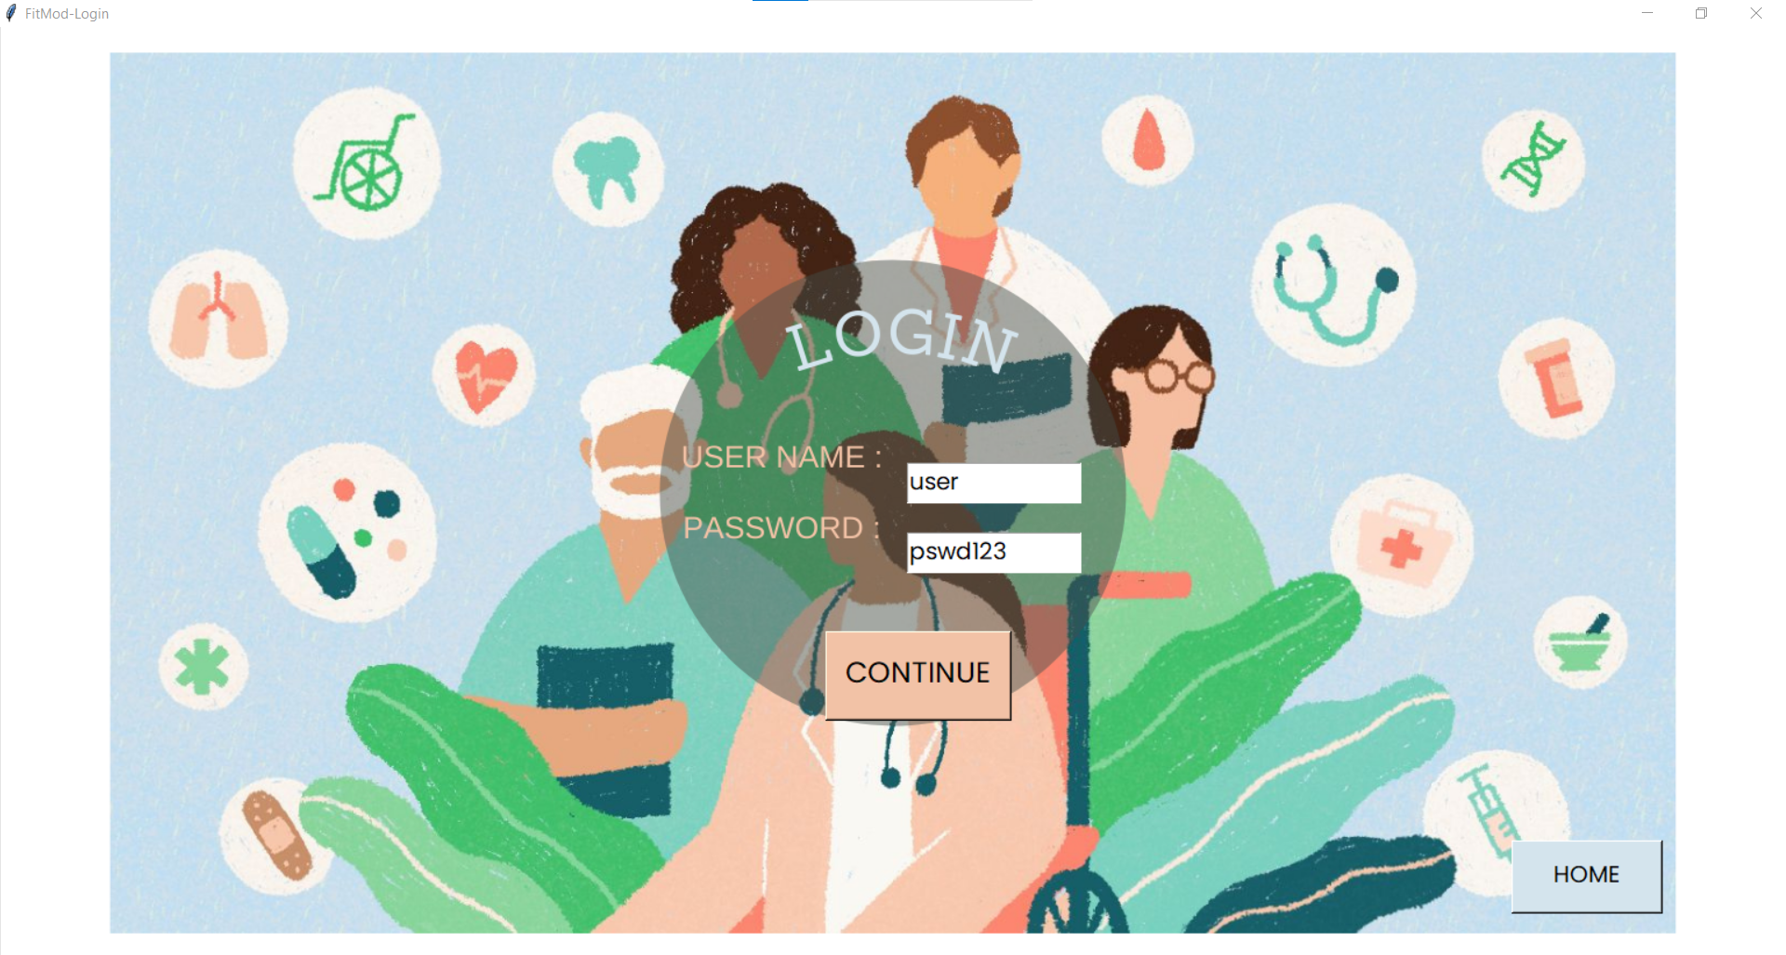

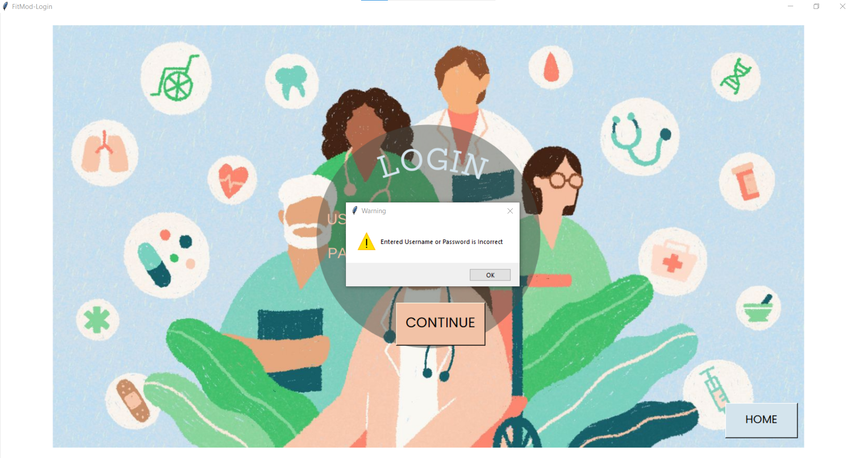

Fig: Warning Message Displayed

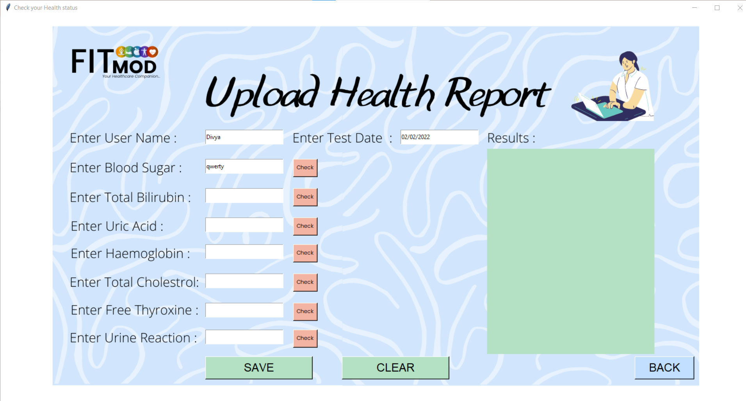

Fig: Entering string values instead of float

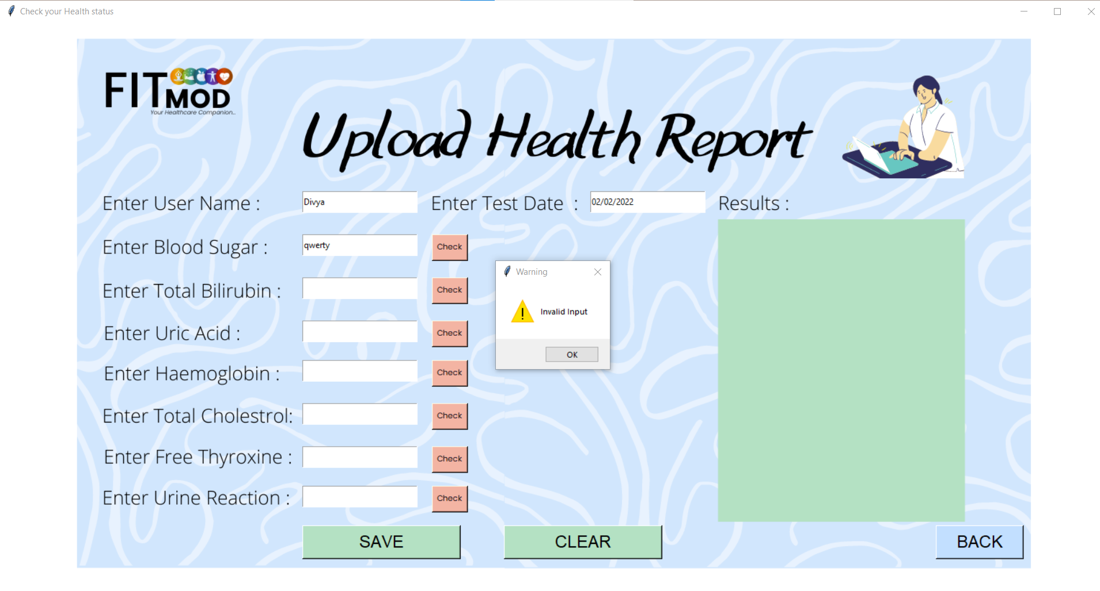

Fig: Error message displayed

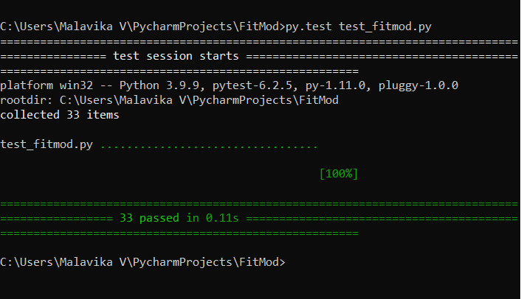

Fig: Testing the program using pytest

**Result and Analysis**

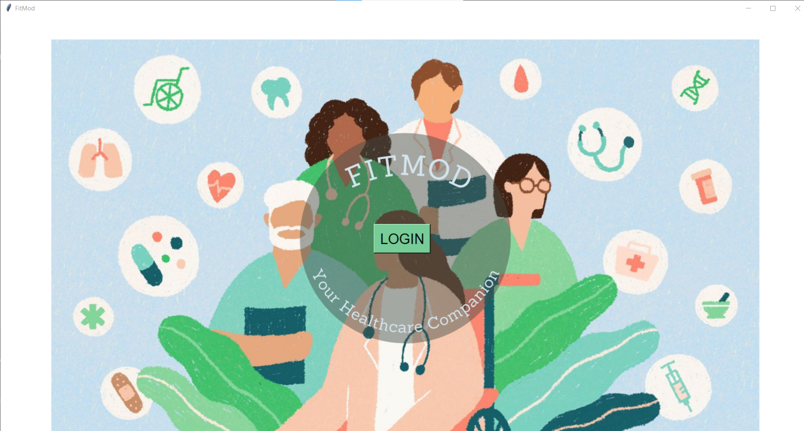

Fig: The Login Page

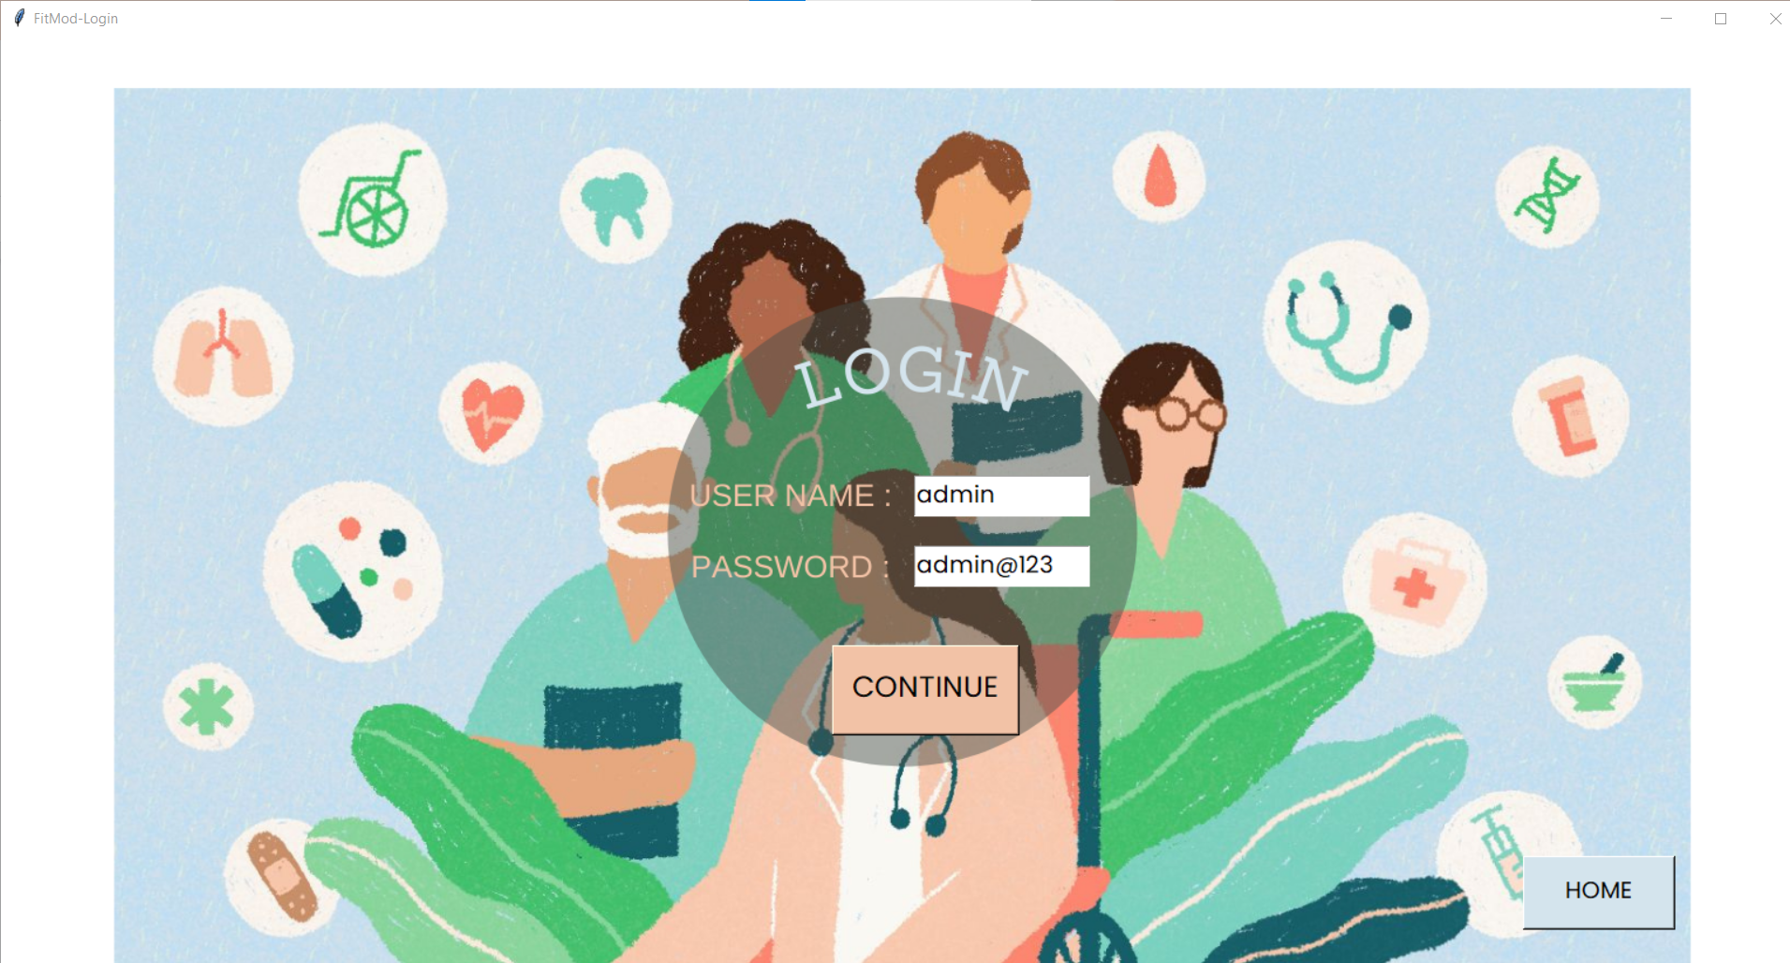

Fig: Entering Login Details

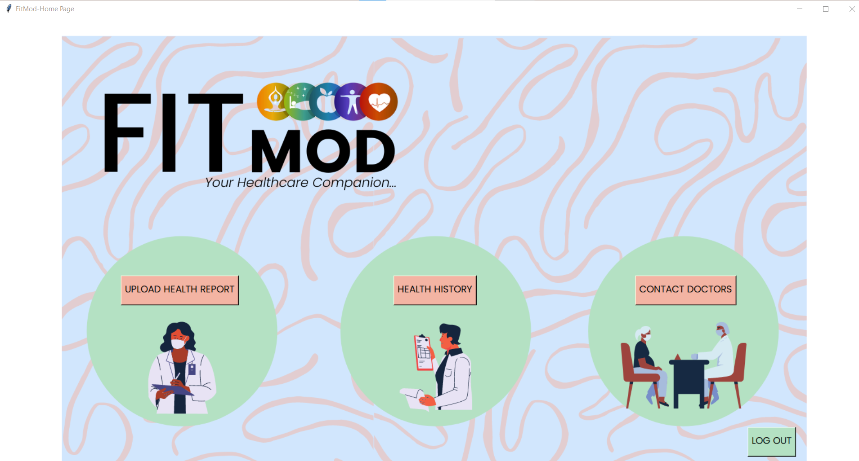

Fig: The Dashboard Page

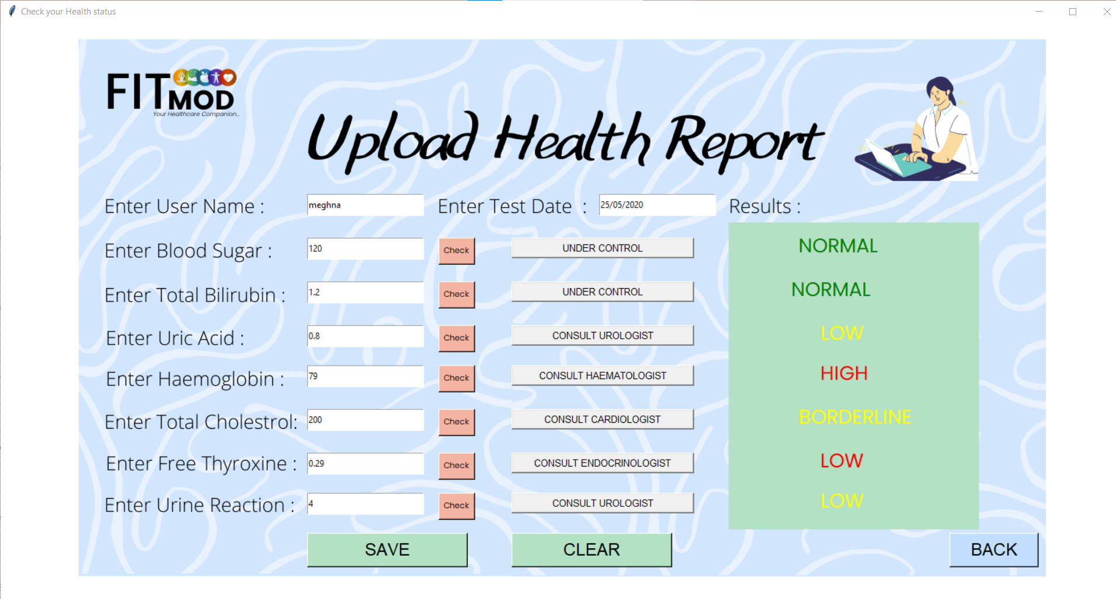

Fig: Checking Health Parameters and Obtaining Corresponding Analysis

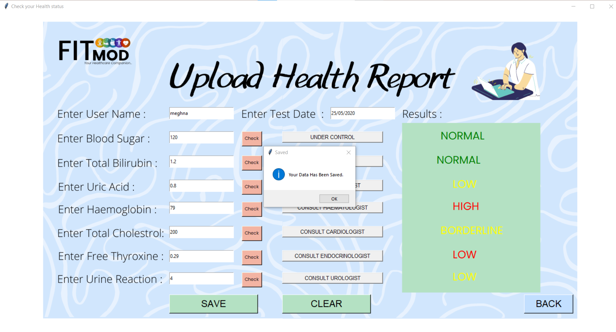

Fig: Saving the Entered Data

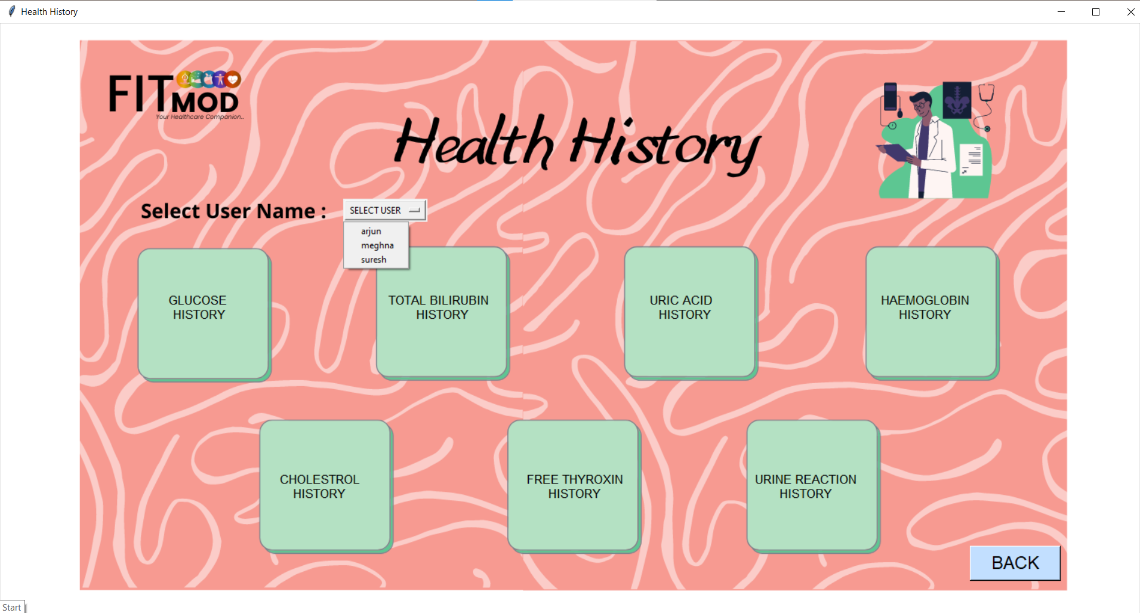

Fig: Health History Page with Available User Options

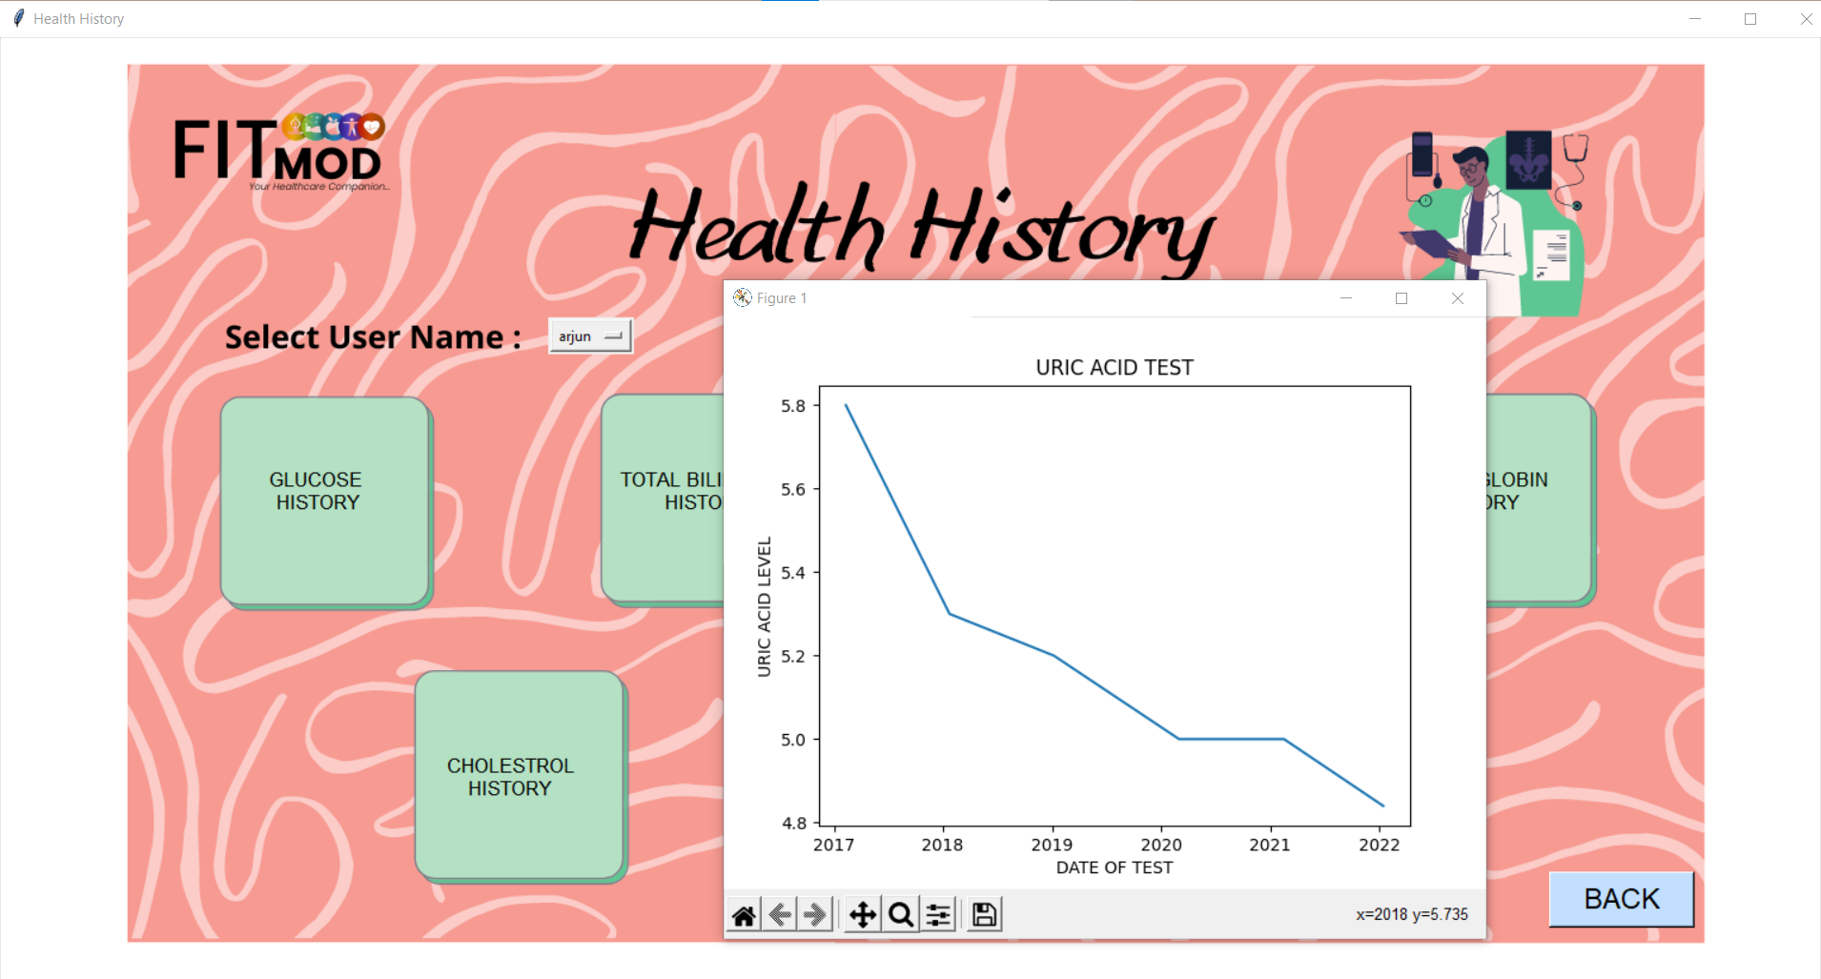

Fig: Data Visualisation Using Graphs

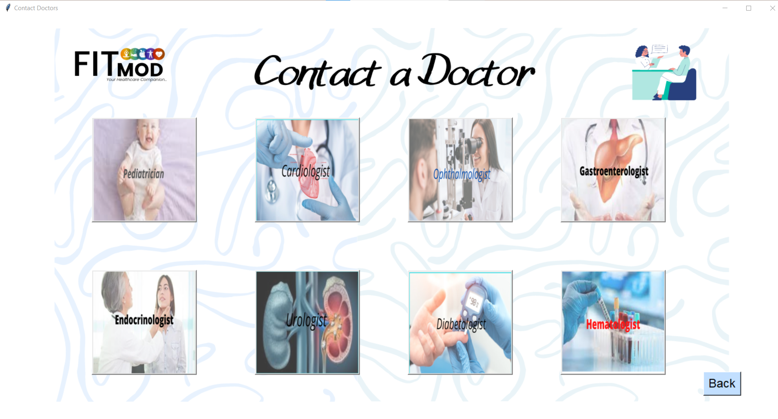

Fig: Viewing Various Health Specialists

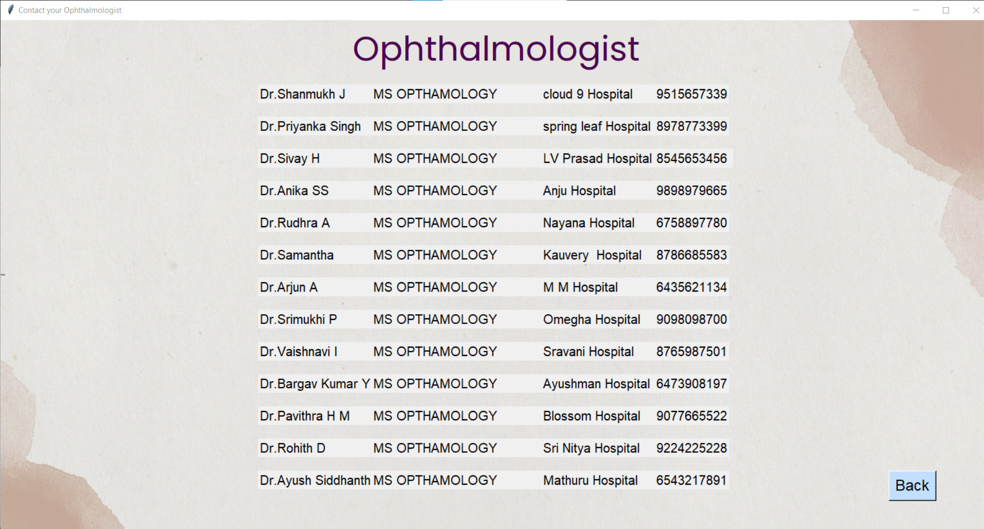

Fig: Contact Information of Doctors

**Conclusions & Future Enhancements**

FitMod is a breakthrough application which has the potential of revolutionising the healthcare industry. The application enables the user to store all health details at a single place without misplacing it. This data can be viewed at any time and helps a user analyse his/her health parameter levels over the years.

The application can further be enhanced by:

* Providing an option to login multiple users
* Including health calculators, like BMI calculator, muscle mass calculator etc.
* A chat bot service to address basic queries
* Scheduling online consultation with doctors
* Including more health parameters to be tracked.

**References**

W3Schools. “Python MySQL”. w3schools.com. https://www.w3schools.com/python/python_mysql_getstarted.asp

GeeksforGeeks. “Python GUI – tkinter”. geeksforgeeks.org. https://www.geeksforgeeks.org/python-gui-tkinter/

W3Schools. “Matplotlib Pyplot”. w3schools.com. https://www.w3schools.com/python/matplotlib_pyplot.asp